SAMPLE ABSTRACT AND PREPARATION INSTRUCTIONS

T. Emplate¹ and I. N. Structions²

¹University of Carbon Nanotubes, Sète, 34200, FRANCE
²Graphene Laboratory, Sète, 34200, FRANCE

The abstracts are limited to text and 2 figures/tables, in ONE page. The Abstract templates are available online in several formats on the conference website: http://www.graphene-and-co.org/?-Annual-meeting-2018 The template shall be completed and sent for submission in pdf format. Please submit your final contribution at https://graph-and-co18.sciencesconf.org/user/submissions
You are also required to go through the administrative subscription procedure, which is divided into two steps. First, authors are required to pre-register to the conference via the online platform from the page https://graph-and-co18.sciencesconf.org/user/registration. Once their subscription is validated, authors will receive a notification e-mail containing a link for final registration and payment. Authors will be able to pay via credit card or bank transfer (please follow the instructions in the invoice generated upon registration).

The GDR Graphene & Co annual meeting conference will be held in Sète, France on October 15-19, 2018, starting on Monday afternoon and closing on Friday, after lunch. This conference welcomes all researchers and engineers interested in the science and applications of Carbon nanotubes, graphene, 2D materials and related materials. All aspects of the physical, chemical or biological properties of these materials will be covered. More precisely, this edition will be organized upon the following topics :Growth and structural properties, Bio and environmental issues, Devices and applications, Processing and functionalization , Theory, Optical properties and Raman spectroscopy, Transport properties, Magnetic properties, Mechanical properties. These topics will be organized into sessions by the committee after the registration/submission process.

References
[1] S. Ample, Proc. MEMS 2008, pp. 100-103.
[2] A. B. Stract and S. Ample, Tech. Digest IEDM 2009, pp. 200-205.
[3] S. Mart and S. O. Lution, J. Journal ., 23 (2006), pp. 300-315.

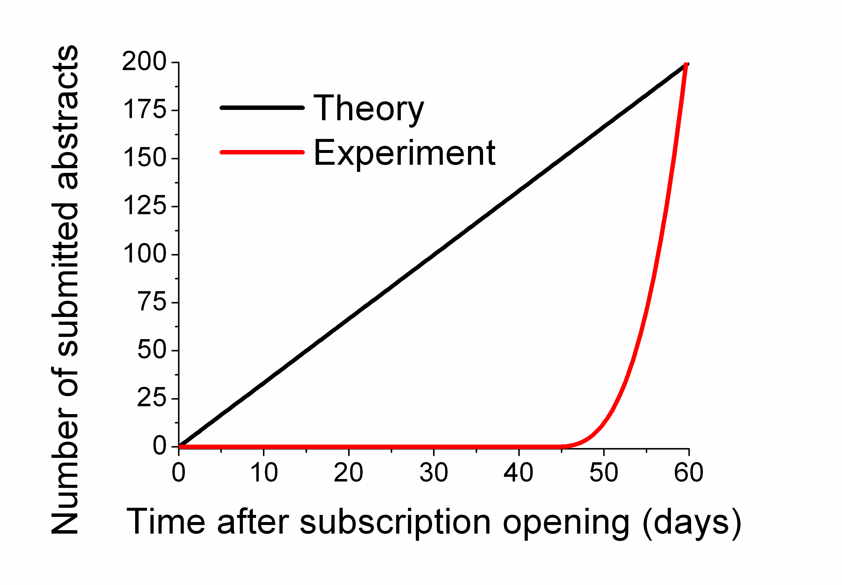
Figure 2 : Number of submitted abstracts versus time : theory in black and experimental values in red.

Figure 1 : Graphene & Co conference logo.

